Project Design Phase-II
Data Flow Diagram & User Stories

Date | 15 April 2026
Team ID | --------------------
Project Name | Project – online Fraud Detection using ML
Maximum Marks | 4 Marks

Data Flow Diagrams:
A Data Flow Diagram (DFD) is a traditional visual representation of the information flows within a system. A neat and clear DFD can depict the right amount of the system requirement graphically. It shows how data enters and leaves the system, what changes the information, and where data is stored.

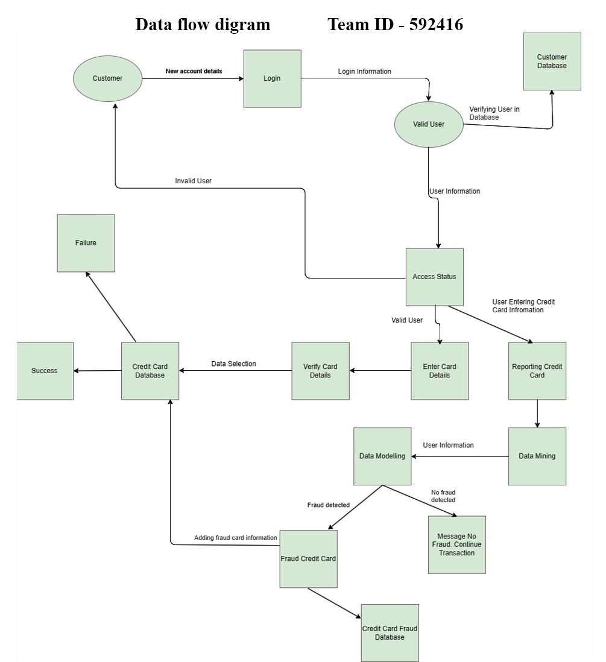

User Stories
Use the below template to list all the user stories for the product.

User Type | Functional  Requirement  (Epic) | User Story Number | User Story / Task | Acceptance criteria | Priority | Release
Customer | Online Shopping | USN-1 | As a customer, I want the system to alert me if a suspicious transaction is detected on my  account. | User receives an alert/notification for suspicious transactions. | High | Sprint-1
 |  | USN-2 | As a customer, I want the system to alert me the  receiver is a potential scammer. | User can view detailed reasons and factors contributing to the suspicious flag. | High | Sprint-3
 |  | USN-4 | As a customer, I should be able to flag the  receiver as scammer. | User can report and provide feedback on flagged | Medium | Sprint-2
 |  | USN-5 | As a user I can register for the application through entering email and password | User is able to register successfully to the platform | High | Sprint-1
Government Organization | Government | USN-1 | Government should be informed about potential scammers who are using fake credit cards, so  that they can take legal actions. | Government is able to fetch data from our servers | Medium | Sprint-3
Administrator | Administration | USN-1 | As an admin, I want to generate monthly reports on the accuracy of the fraud detection system. | Admin can generate and download reports on false positives, false negatives, and overall accuracy. | High | Sprint-3
 |  | USN-2 | As an admin, I want to view a dashboard summarizing all detected fraud attempts in the  past month. | Admin can view dashboard with summaries, charts, and details of fraud attempts. | Medium | Sprint-3

